Nguyễn Lê Thịnh_1250080186_CNTT4
Bài Tập Lý Thuyết Buổi 5

Bài 1:
CREATE TABLE TUYEN (
MATUYEN VARCHAR2(10) PRIMARY KEY,
BENDAU VARCHAR2(50),
BENCUOI VARCHAR2(50),
GIATUYEN NUMBER,
NGXB DATE,
TGDK NUMBER
);

CREATE TABLE XE (
MAXE VARCHAR2(10) PRIMARY KEY,
BIENKS VARCHAR2(20),
MATUYEN VARCHAR2(10),
SOGHET1 NUMBER,
SOGHET2 NUMBER,
CONSTRAINT FK_XE_TUYEN FOREIGN KEY (MATUYEN) REFERENCES TUYEN(MATUYEN)
);

CREATE TABLE KHACH (
MAHK VARCHAR2(10) PRIMARY KEY,
HOTEN VARCHAR2(50),
GIOITINH VARCHAR2(10),
CMND VARCHAR2(20)
);

CREATE TABLE VEXE (
MATUYEN VARCHAR2(10),
MAHK VARCHAR2(10),
NGMUA DATE,
GIAVE NUMBER,
PRIMARY KEY (MATUYEN, MAHK, NGMUA),
CONSTRAINT FK_VEXE_TUYEN FOREIGN KEY (MATUYEN) REFERENCES TUYEN(MATUYEN),
CONSTRAINT FK_VEXE_KHACH FOREIGN KEY (MAHK) REFERENCES KHACH(MAHK)
);

INSERT INTO TUYEN VALUES ('T11A', 'SG', 'DL', 210000, TO_DATE('26/12/2016', 'DD/MM/YYYY'), 6);
INSERT INTO TUYEN VALUES ('T32D', 'PT', 'SG', 120000, TO_DATE('30/12/2016', 'DD/MM/YYYY'), 4);
INSERT INTO TUYEN VALUES ('T06F', 'NT', 'DNG', 225000, TO_DATE('02/01/2017', 'DD/MM/YYYY'), 7);

INSERT INTO XE VALUES ('X01', '52LD-4393', 'T11A', 20, 20);
INSERT INTO XE VALUES ('X02', '59LD-7247', 'T32D', 36, 36);
INSERT INTO XE VALUES ('X03', '55LD-6850', 'T06F', 15, 15);

INSERT INTO KHACH VALUES ('KH01', 'Lâm Văn Bền', 'Nam', '655615896');
INSERT INTO KHACH VALUES ('KH02', 'Dương Thị Lục', 'Nữ', '275648642');
INSERT INTO KHACH VALUES ('KH03', 'Hoàng Thanh Tùng', 'Nam', '456889143');

INSERT INTO VEXE VALUES ('T11A', 'KH01', TO_DATE('20/12/2016', 'DD/MM/YYYY'), 210000);
INSERT INTO VEXE VALUES ('T32D', 'KH02', TO_DATE('25/12/2016', 'DD/MM/YYYY'), 144000);
INSERT INTO VEXE VALUES ('T06F', 'KH03', TO_DATE('30/12/2016', 'DD/MM/YYYY'), 270000);
COMMIT;

ALTER TABLE TUYEN ADD CONSTRAINT CHK_TGDK_GIA CHECK (TGDK <= 5 OR GIATUYEN > 200000);

CREATE OR REPLACE TRIGGER TRG_TANG_GIAVE
BEFORE INSERT OR UPDATE ON VEXE
FOR EACH ROW
DECLARE
V_NGXB DATE;
V_GIATUYEN NUMBER;
BEGIN
SELECT NGXB, GIATUYEN INTO V_NGXB, V_GIATUYEN
FROM TUYEN
WHERE MATUYEN = :NEW.MATUYEN;

IF V_NGXB BETWEEN TO_DATE('29/12/2016', 'DD/MM/YYYY') AND TO_DATE('05/01/2017', 'DD/MM/YYYY') THEN
:NEW.GIAVE := V_GIATUYEN * 1.2;
END IF;
END;
/

SELECT * FROM VEXE
WHERE EXTRACT(MONTH FROM NGMUA) = 12
ORDER BY GIAVE DESC;
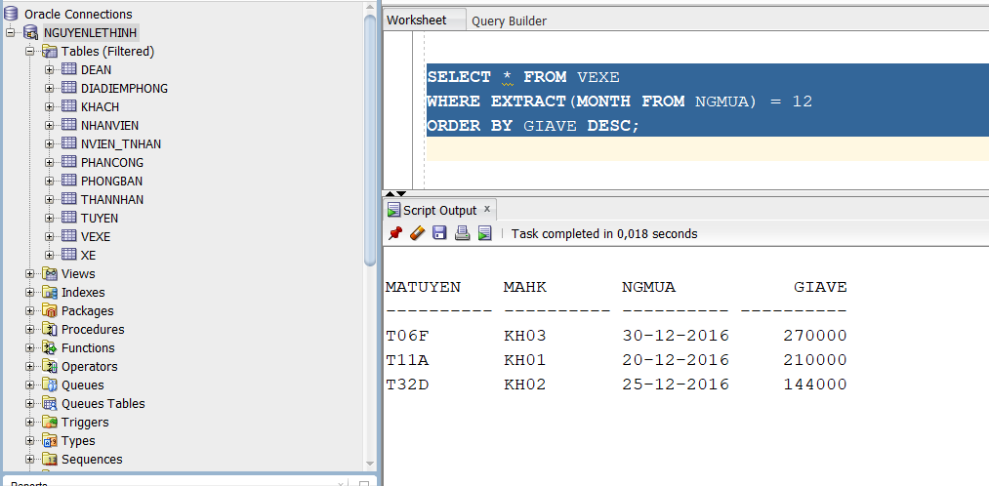

SELECT MATUYEN, COUNT(MAHK) AS SO_LUONG_VE
FROM VEXE
WHERE EXTRACT(YEAR FROM NGMUA) = 2016
GROUP BY MATUYEN
HAVING COUNT(MAHK) <= ALL (
SELECT COUNT(MAHK)
FROM VEXE
WHERE EXTRACT(YEAR FROM NGMUA) = 2016
GROUP BY MATUYEN
);
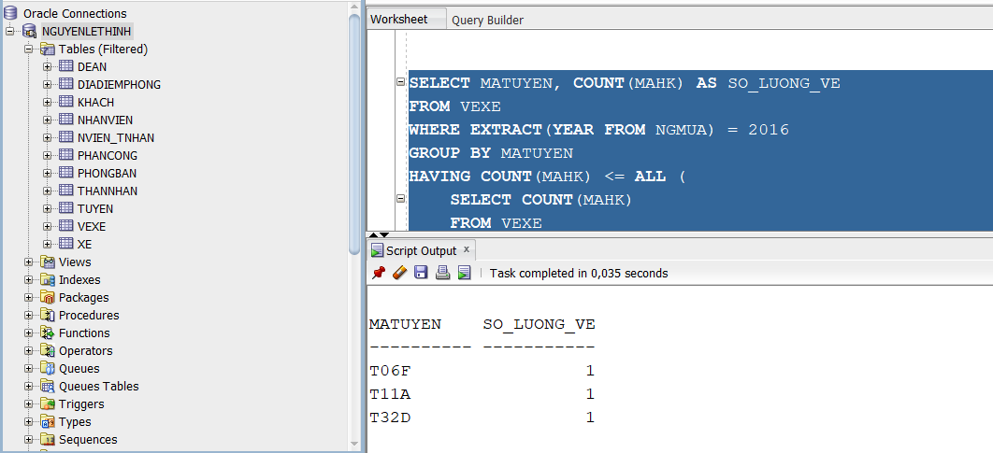

SELECT V.MATUYEN
FROM VEXE V JOIN KHACH K ON V.MAHK = K.MAHK
WHERE K.GIOITINH = 'Nam'
INTERSECT
SELECT V.MATUYEN
FROM VEXE V JOIN KHACH K ON V.MAHK = K.MAHK
WHERE K.GIOITINH = 'Nữ';
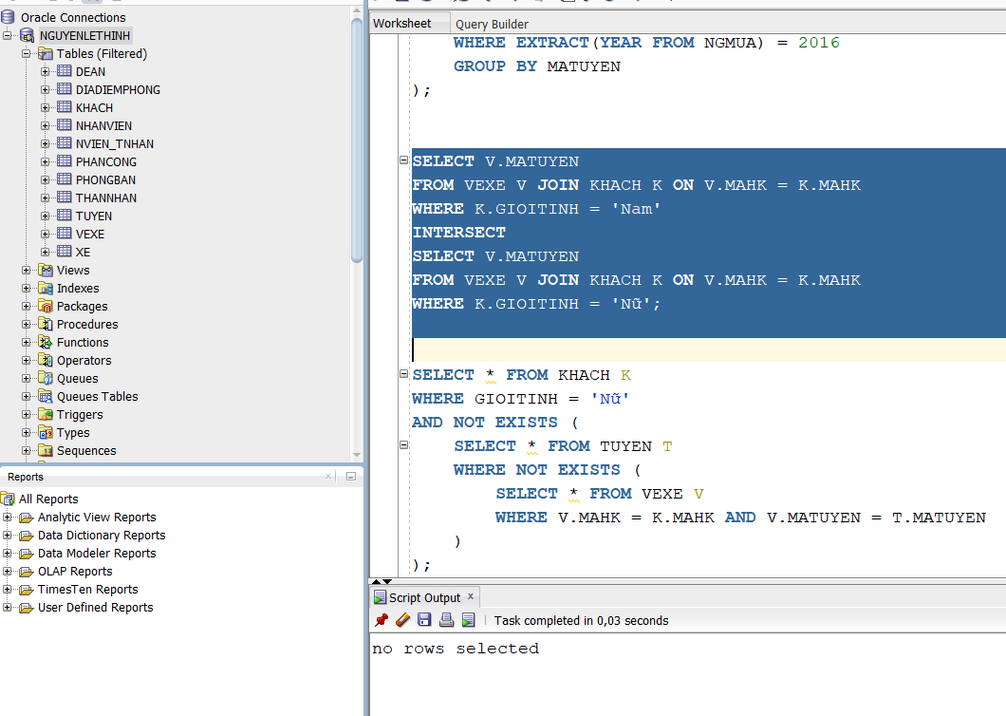

SELECT * FROM KHACH K
WHERE GIOITINH = 'Nữ'
AND NOT EXISTS (
SELECT * FROM TUYEN T
WHERE NOT EXISTS (
SELECT * FROM VEXE V
WHERE V.MAHK = K.MAHK AND V.MATUYEN = T.MATUYEN
)
);

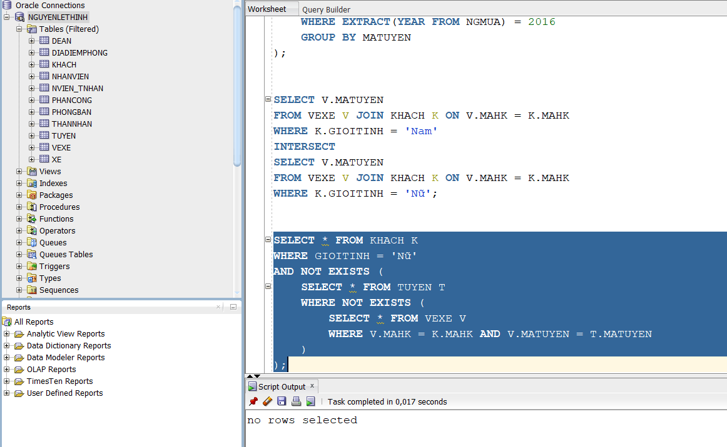

Bài 2 :

CREATE TABLE NGUOIDUNG (
UID_USER VARCHAR2(10) PRIMARY KEY,
USERNAME VARCHAR2(50),
PASS VARCHAR2(50),
REGDAY DATE,
NATIONALITY VARCHAR2(50)
);

CREATE TABLE CHANNEL (
CHANNELID VARCHAR2(10) PRIMARY KEY,
CNAME VARCHAR2(50),
SUBSCRIBES NUMBER,
OWNER VARCHAR2(10),
CREATED DATE,
CONSTRAINT FK_CHANNEL_USER FOREIGN KEY (OWNER) REFERENCES NGUOIDUNG(UID_USER)
);

CREATE TABLE VIDEO (
VIDEOID VARCHAR2(10) PRIMARY KEY,
TITLE VARCHAR2(100),
DURATION NUMBER,
AGE NUMBER
);

CREATE TABLE SHARE_VIDEO (
VIDEOID VARCHAR2(10),
CHANNELID VARCHAR2(10),
PRIMARY KEY (VIDEOID, CHANNELID),
CONSTRAINT FK_SHARE_VIDEO FOREIGN KEY (VIDEOID) REFERENCES VIDEO(VIDEOID),
CONSTRAINT FK_SHARE_CHANNEL FOREIGN KEY (CHANNELID) REFERENCES CHANNEL(CHANNELID)
);

INSERT INTO NGUOIDUNG VALUES ('001', 'faptv', '123456abc', TO_DATE('01/01/2014', 'DD/MM/YYYY'), 'Việt Nam');
INSERT INTO NGUOIDUNG VALUES ('002', 'kemxoitv', '@147869iii', TO_DATE('05/06/2015', 'DD/MM/YYYY'), 'Campuchia');
INSERT INTO NGUOIDUNG VALUES ('003', 'openshare', 'qwertyuiop', TO_DATE('12/05/2009', 'DD/MM/YYYY'), 'Việt Nam');

INSERT INTO CHANNEL VALUES ('C120', 'FAP TV', 2343, '001', TO_DATE('02/01/2014', 'DD/MM/YYYY'));
INSERT INTO CHANNEL VALUES ('C905', 'Kem xôi TV', 1032, '002', TO_DATE('09/07/2015', 'DD/MM/YYYY'));
INSERT INTO CHANNEL VALUES ('C357', 'OpenShare Cáfe', 5064, '003', TO_DATE('10/12/2010', 'DD/MM/YYYY'));

INSERT INTO VIDEO VALUES ('V100229', 'FAPtv Cơm Nguội Tập 41 - Đột Nhập', 469, 18);
INSERT INTO VIDEO VALUES ('V211002', 'Kem xôi: Tập 31 - Mẩy Kool tình yêu của anh', 312, 16);
INSERT INTO VIDEO VALUES ('V400002', 'Nơi tình yêu kết thúc - Hoàng Tuấn', 378, 0);

INSERT INTO SHARE_VIDEO VALUES ('V100229', 'C905');
INSERT INTO SHARE_VIDEO VALUES ('V211002', 'C120');
INSERT INTO SHARE_VIDEO VALUES ('V400002', 'C357');
COMMIT;

ALTER TABLE NGUOIDUNG MODIFY REGDAY DEFAULT SYSDATE;

CREATE OR REPLACE TRIGGER TRG_CHECK_NGAY_TAOKENH
BEFORE INSERT OR UPDATE ON CHANNEL
FOR EACH ROW
DECLARE
V_REGDAY DATE;
BEGIN
SELECT REGDAY INTO V_REGDAY FROM NGUOIDUNG WHERE UID_USER = :NEW.OWNER;

IF :NEW.CREATED < V_REGDAY THEN
RAISE_APPLICATION_ERROR(-20001, 'Ngày tạo kênh phải lớn hơn hoặc bằng ngày đăng ký!');
END IF;
END;
/

-- 5
SELECT * FROM VIDEO WHERE AGE >= 16;
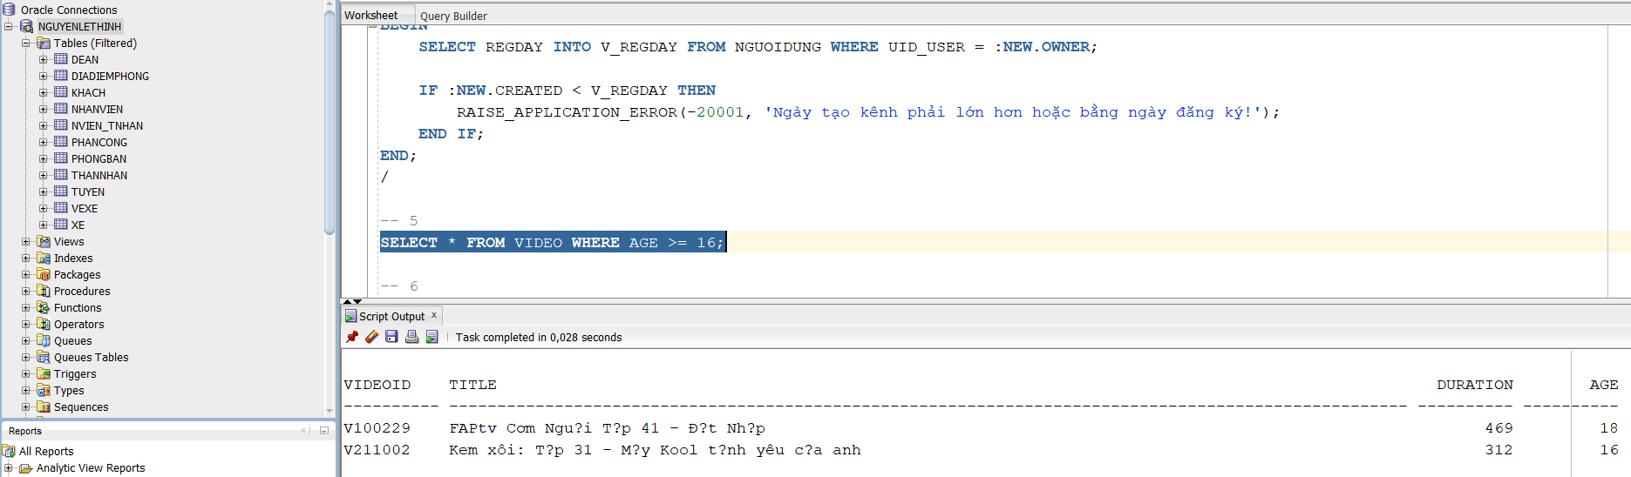
-- 6
SELECT * FROM CHANNEL
WHERE SUBSCRIBES = (SELECT MAX(SUBSCRIBES) FROM CHANNEL);
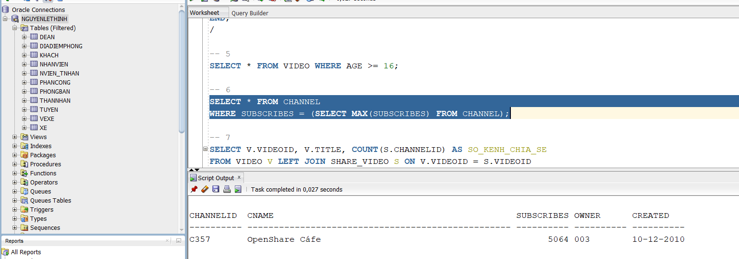
-- 7
SELECT V.VIDEOID, V.TITLE, COUNT(S.CHANNELID) AS SO_KENH_CHIA_SE
FROM VIDEO V LEFT JOIN SHARE_VIDEO S ON V.VIDEOID = S.VIDEOID
WHERE V.AGE = 18
GROUP BY V.VIDEOID, V.TITLE;
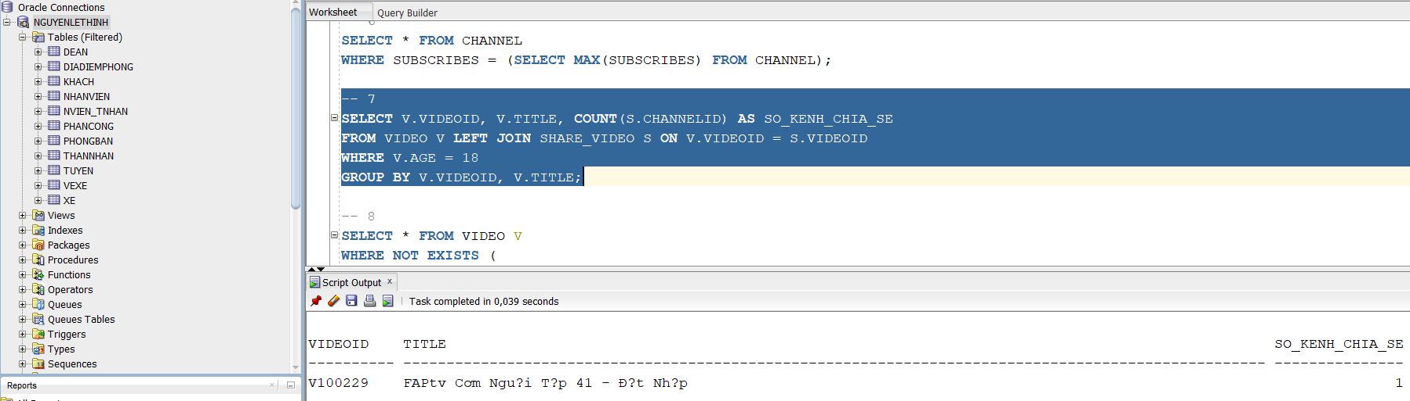
-- 8
SELECT * FROM VIDEO V
WHERE NOT EXISTS (
SELECT * FROM CHANNEL C
WHERE NOT EXISTS (
SELECT * FROM SHARE_VIDEO S
WHERE S.VIDEOID = V.VIDEOID AND S.CHANNELID = C.CHANNELID
)
);
